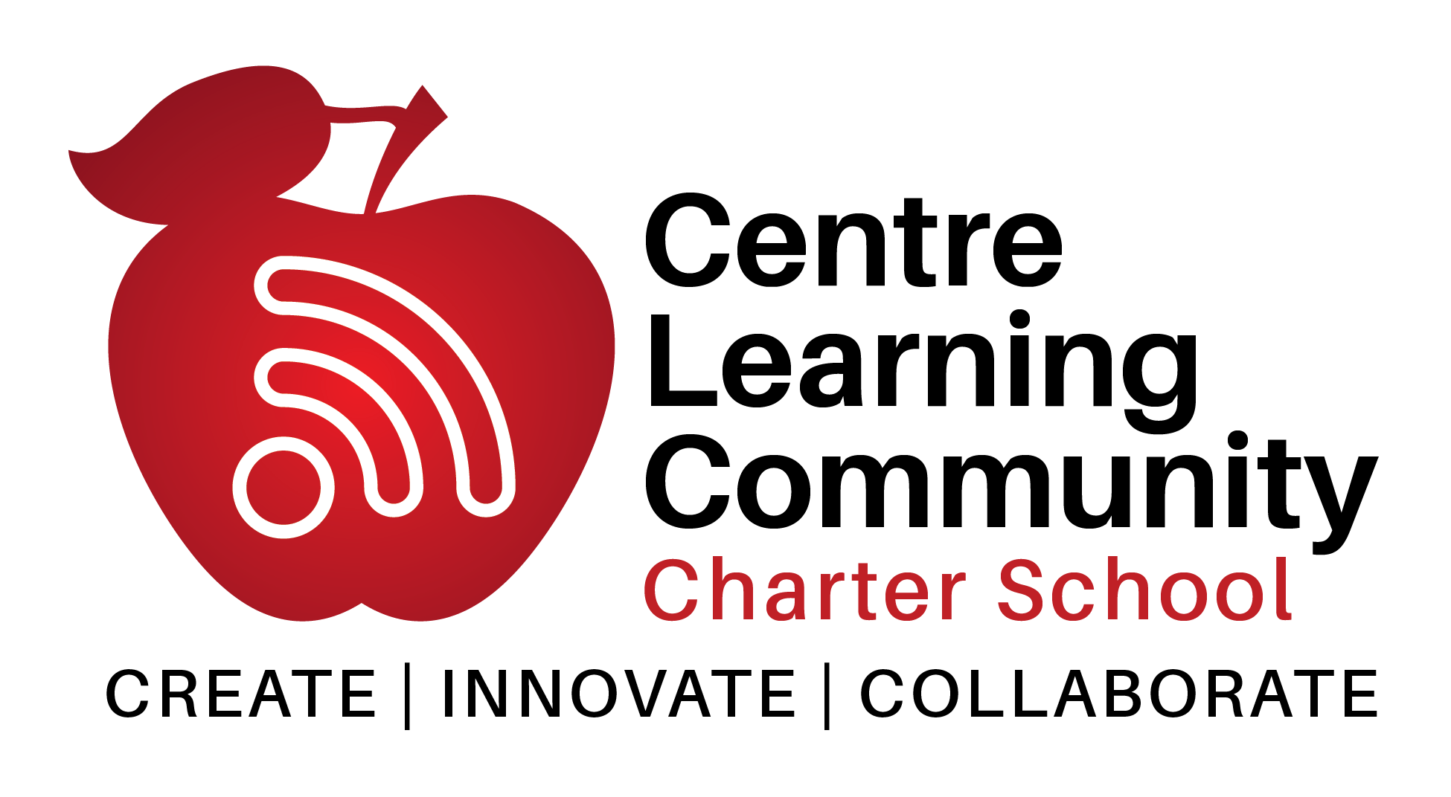

Hello CLC 8th Grade Families,

All of our 8th graders have chosen to take the 8th Grade Specials Class during the first specials blocks this year. During this class, all students will create proposals for an 8th grade trip, which is tentatively scheduled for May 31st. Students will also create fundraising plans to cover the costs of the end-of-year 8th grade trip. Assignment details can be found on our 8th grade website:

http://clc8th.weebly.com

As a parent/guardian of a CLC 8th grader, we request that you help by attending any future fundraisers and provide food for fundraising events when possible. Once our team of 8th graders has decided on fundraising plans, we will pass along dates and details.

In the past, the 8th grade class has gone to New York City, Ohio, Baltimore, and Hershey for day trips. At times, not all parents have opted for their child to go on the 8th grade trip. We encourage everyone to allow their child to participate in this special opportunity, but understand reservations that people may have. Please let us know as soon as possible if your child will not be allowed to go on the trip so that we can schedule your child in other specials offerings.

Let us know if you have any questions,
Brian, Morgan,& Marcy
Bottom of Form

